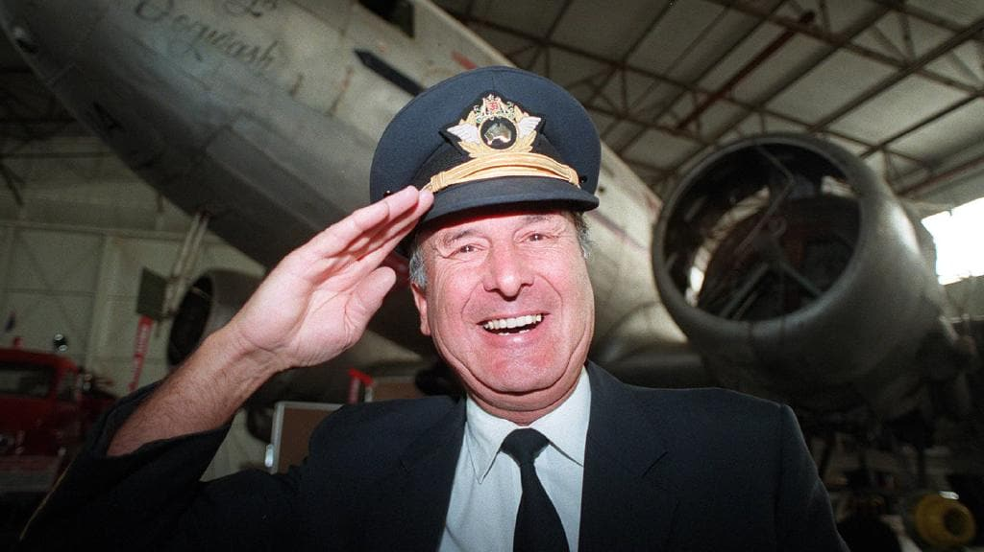SA pilot Dick Lang.

SA NEWS

Obituaries: ‘Desert’ Dick Lang and son Dr Clayton Lang killed in Kangaroo Island bushfire
Craig Cook, Sunday Mail (SA)
January 5, 2020 12:53pm
Subscriber only
- Bush pilot Dick Lang, son Clayton killed in KI bushfire
- Are you getting the most from your Advertiser subscription?
Known as a modern day Indiana Jones, Dick Lang spent a lifetime beating the odds.
At the age of 46, the pilot, pioneer and former roo shooter was given less than six months to live in 1988.
He underwent treatment at the Royal Adelaide Hospital for multiple myeloma, a rare form of bone marrow cancer.
His doctors put a large part of his full and rapid recovery down to a “healthy positive attitude”.
Lang always exuded confidence and he needed that and more to forge a successful adventure business in the rugged and remote Australian Outback.
Rock widow’s bizarre wedding date
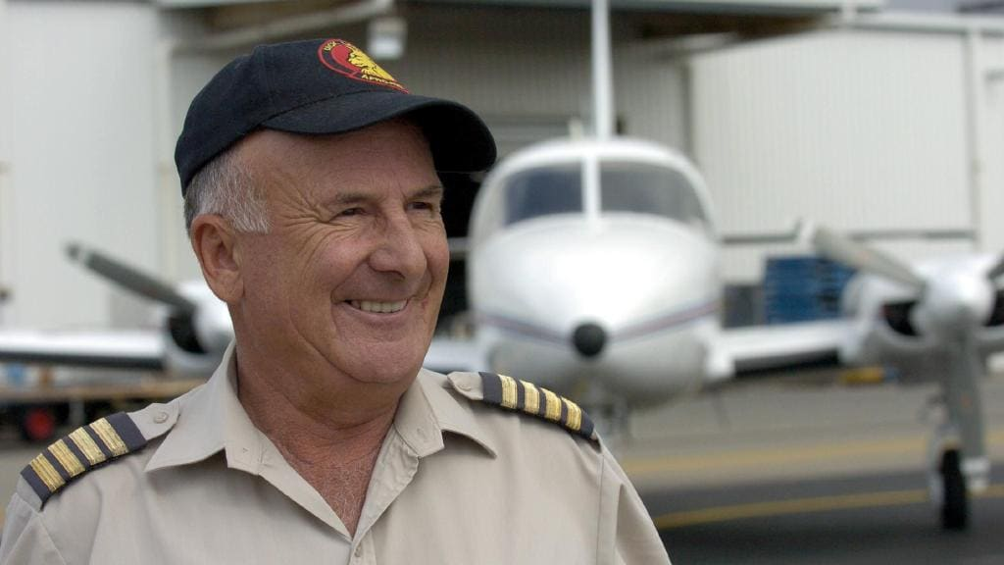Adventurer and pilot Dick Lang.

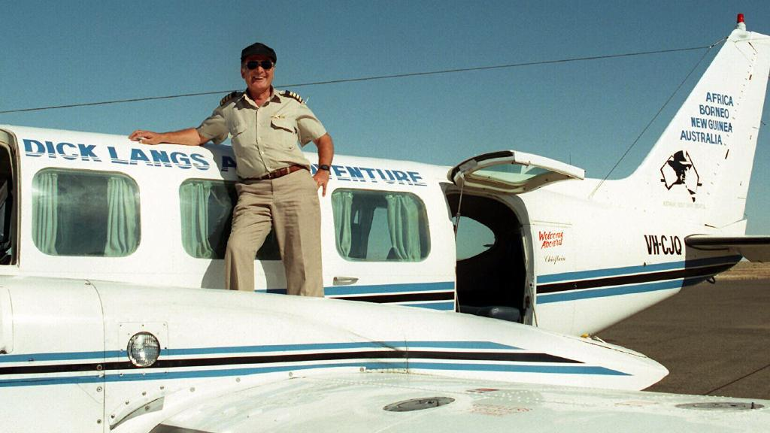
Dick Lang with one of his planes.

It was late 1965 when Lang, and wife Helen, both school teachers at Port Pirie High School set up a weekend four-wheel-drive safari business.
Desert-Trek became well-known in the South Australian Outback with the first day trips, out to the nearby Flinders Ranges, charging customers 5 pounds each.
During longer ventures during school holidays they explored the notorious Birdsville Track and Strzelecki Desert.
Soon they were the biggest 4WD Adventure company in the world with 10 Land Rovers, a large bus and two aircraft.

In 1969, the Langs shifted to Highbury in Adelaide’s north east, and the business rocketed flying operations over Lake Eyre and later into WA’s rugged Kimberleys, Cape York, at the top of Queensland and across Tasmania.
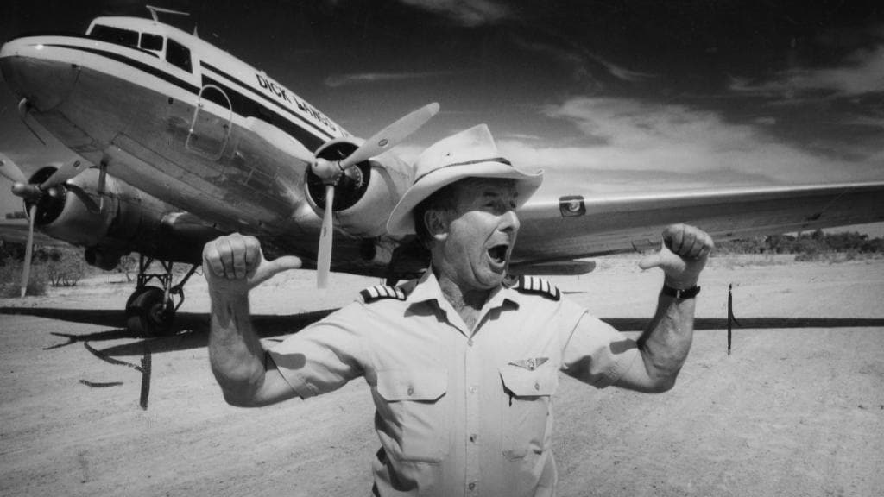
Pilot bushman outback tour operator Dick Lang on the runway at Nappamerrie Station after landing a DC-3 aeroplane on the bush strip in outback Queensland in 1993.
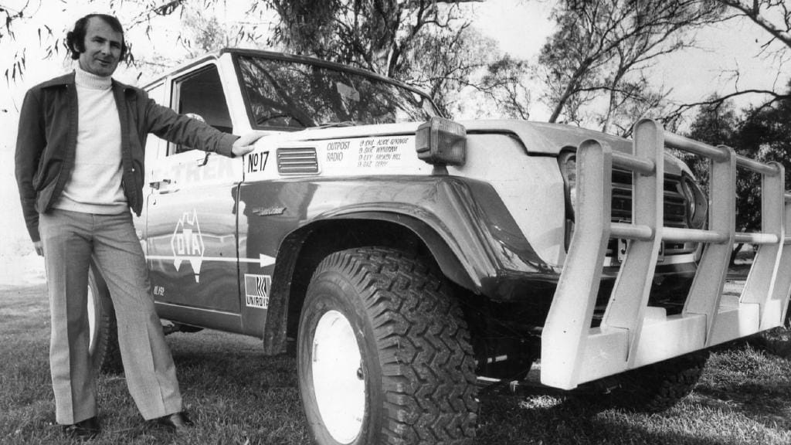
Dick Lang in 1978.

Lang continued to teach, at Norwood High School until 1974 when Lake Eyre flooded for the first time in recorded history creating an unmissable tourism opportunity.
He set a world record on the Lake that year for the longest water ski in history.
With cash in the bank and in a bold move, in 1978 the Langs, expanded their operations to the treacherous highlands of Papua New Guinea.
During his health scare and in “a bitter blow” Lang sold Desert-Trek, to a friend based in the Northern Territory.
A lover of luxury cars and an avid collected of antiquities he also sold two vintage Porsche a valuable collection of rare pistols and rifles and a string of camels.
But a few years later the Langs, with four sons, were back in big time business with “Lang’s Desert-Air”.
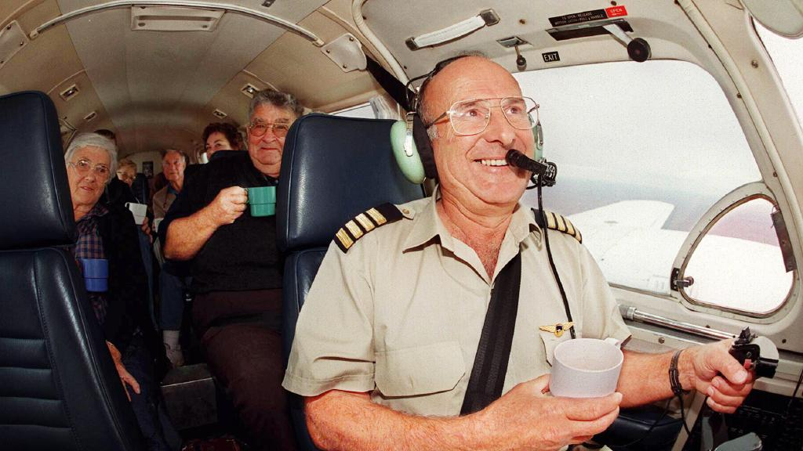Dick Lang and passengers flying over a flooded Lake Eyre.

In the 1990s they spent a decade running safari tours in Africa under the name “Afro Trek”, commuting between Australia and the Dark Continent.
In 2004, the then 62-year-old looked to sell up again and retire but was still operating tours in 2015 for a 50th anniversary as ‘Desert’ Dick Lang.
Lang claimed his ancestors were on board the Buffalo when it landed at Glenelg in 1836 as some of the first white settlers of South Australia but it was the remote desert landscapes, not the sea, that he loved.
“Deserts exhibit an untouched beauty,” he said.
“One of the greatest thrills in the Outback is to wake up early and see clean-swept sand, with perhaps a set of dingo tracks running across it.
“That is freedom; freedom and beauty both.’’

CLAYTON LANG
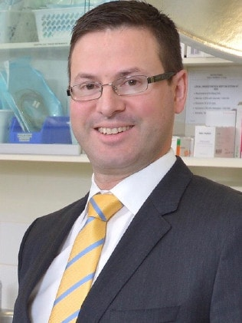
Clayton Lang.

The highly respected surgeon was instrumental to the treatment of advanced melanoma and was described to have “a larger than life personality”, his colleagues at the Queen Elizabeth Hospital mourn.
One of four sons of Outback safari pioneers, Dick and Helen Lang, born in 1975, Clayton Lang was one of the state’s leading plastic surgeons.
The 43-year-old was Senior Staff Specialist at The QEH Woodville and had a private consultancy with Dextra Surgical on South Terrace.
The hospital’s Head of Plastic and Reconstrictive Surgery, Tim Proudman, said Mr Lang was a “highly valued” lead clinicians at the Hand Surgery Clinic, focusing on patients with melanoma.
“It is such a tragedy that Clayton and his father Dick, were lost to us,” he said.
“Clayton was providing high level advanced health care to his patients, contributing to the development of surgical knowledge and was a respected member of our Unit and of the plastic surgical community in SA.
“We knew him both professionally and personally as an individual of great value.
“He still had more to contribute and he will be sorely missed by all members of the Plastic and Reconstructive Unit at TQEH.
“We extend our deepest sympathies to all his family.”
Mr Lang set up a combined clinic managing advanced melanoma surgeries and trained future plastic surgeons.
A graduate of the University of Adelaide medical school in 2001, Lang worked across Australia.
He returned to Adelaide from Queensland in 2014 to join Sach Day Surgery, later Dextra, in a partnership with fellow plastic surgeons, Randall Sach and Markus Nikitins.
Mr Sach, the long-term partner of the TV and radio personality Jane Reilly said news of the death of his close colleague was “tragic”.
“His death will come as a great shock and loss to the Plastic Surgery fraternity at large, and to the many grateful patients he has helped over the years,” Mr Sachs who retired recently said.
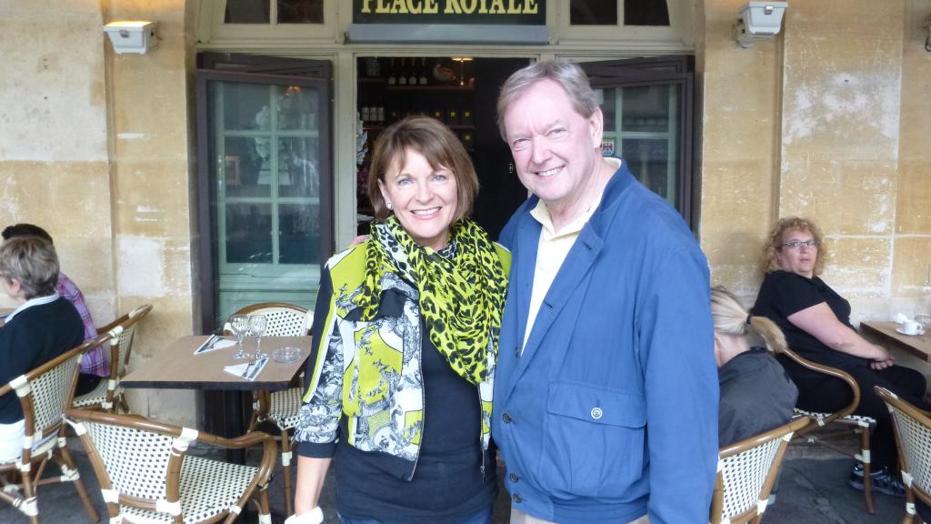Jane Reilly and partner Randall Sach in Paris.

“He was a very talented, popular and personable Surgeon who held the respect of his colleagues and workmates in pursuing excellence in his surgical skills with strong commitments to both Public and Private Plastic Surgery practices.
“Patients frequently provided glowing feedback of his care and devotion.
“As a still young Surgeon and young man, to be denied the opportunity to fulfil his full potential is a dreadful tragedy that will resonate widely through our community.”
Mr Lang, with a specialty interest in hand surgery, married his wife Christie, an anaesthetist, at the Glen Ewin Estate in 2009.
The couple has two daughters, Sophia and Madeline.

